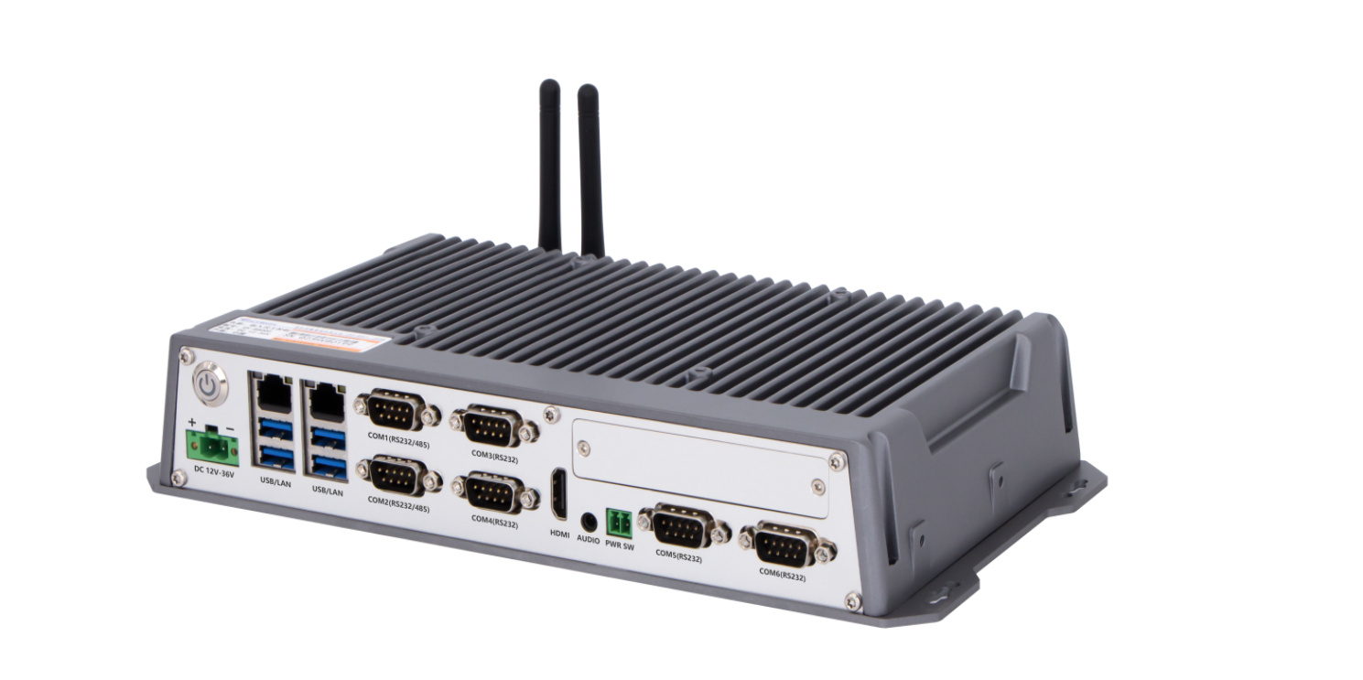
Industrial Mini PC
QY-B8000
Compound Series

Products Features:
- Industrial-Grade Embedded Fanless Mini PC
- Intel Celeron and Core 4/7/8/10/12th-i3 / i5 / i7 CPU
- 2*LAN, 4*USB, 6*COM, 1*HDMI
- 1*Expansion Slot, Support 4G/5G and WIFI module
- DC 9-36V Power Input With Overvoltage Protection
- -30℃~70℃ Temperature Can Keep 24/7 Work Stably
- 1*Multifunctional Daughter card slot
- Anti-Static, Anti-Pulse, Anti-Surge, Anti-Radiation
QY-B8000
1-1.Mother Board Specification:
Model | QY-B8000
CPU | J1900  i3-4010U  i5-4260U  i7-4650U
Memory^{[1]} | 2*DDR III RAM Slots, Up to 16GB
Storage | 1*MSATA Slot  1*SATA SSD Slot
Display^{[2]} | 1*HDMI: Resolution up to 4096*2106@24Hz
Expansion | 1*Mini PCIE Slot, Support 4G and WIFI module
Ethernet | 2*Intel i210v LAN Chip (10 / 100 / 1000 Mbps, RJ-45 Type)
USB | 4*USB 3.0 (Type-A)
COM | 2*RS-232 / 422 / 485 (DB9 type)  4*RS-232 (DB9 type)
Audio | 1*Line-Out
Daughter Card | Support expansion more I/O interfaces and functional slots
Notes:
[1]: The maximum memory capacity and the maximum capacity per strip supported by this motherboard depend on the CPU. J1900 CPU only supports one RAM slot, up to 8GB.
[2]: The maximum resolution and frame rate of the display interface output depends on the CPU.

QY-B8000
1-2.Mother Board Specification:
Model | QY-B8000
CPU | J6412 / N95 / N100  i3: 7100U / 8130U / 10110U  i5: 7200U / 8250U / 8260U / 10210U  i7: 7500U / 8550U / 10710U
Memory^{[1]} | 2*DDR IIII RAM Slots, Up to 32GB
Storage | 1*MSATA SSD Slot  1*SATA SSD Slot
Display^{[2]} | 1*HDMI: Resolution up to 4096*2106@24Hz
Expansion | 1*Mini PCIE Slot, Support 4G and WIFI module
Ethernet | 2*Intel i210v LAN Chip (10 / 100 / 1000 Mbps, RJ-45 Type)
USB | 4*USB 3.0 (Type-A)
COM | 2*RS-232 / 422 / 485 (DB9 type)  4*RS-232 (DB9 type)
Audio | 1*Line-Out
Daughter Card | Support expansion more I/O interfaces and functional slots
Notes:
[1]: The maximum memory capacity and the maximum capacity per strip supported by this motherboard depend on the CPU.
[2]: The maximum resolution and frame rate of the display interface output depends on the CPU.

QY-B8000
1-3.Mother Board Specification:
Model | QY-B8000
CPU | i3: 1115G4 / 1215U  i5: 1135G7 / 1235U  i7: 1195G7 / 1255U / 1270P
Memory | 2*DDR IIII RAM Slots, Up to 64GB
Storage | 1*M.2 NVME SSD Slot
Display | 1*HDMI: Resolution up to 4096*2106@60Hz
Expansion | 1*Mini PCIE +1*M.2 Slots, Support 4G/5G and WIFI module
Ethernet | 2*Intel i210v LAN Chip (10 / 100 / 1000 Mbps, RJ-45 Type)
USB | 4*USB 3.0 (Type-A)
COM | 2*RS-232 / 422 / 485 (DB9 type)  4*RS-232 (DB9 type)
Audio | 1*Line-Out
Daughter Card | Support expansion more I/O interfaces and functional slots

2.Device Specification:
QY-B8000
Watch Dog | Support
Power Input | DC 9-36V With Overvoltage Protection
Power Input | Support Auto-Start
Power Input | 2 Pin Phoenix Terminal Type DC Plug
Working Temperature | -30℃~70℃, Support 24/7 Working
Structure | Fully Enclosed Aluminum Alloy Material
Heat Dissipation | Fanless Design, Conduction Heat Dissipation
Installation | Desktop / Embedded / Wall Mount
Size | 285mm*160mm*50.5mm
System | Windows and Linux

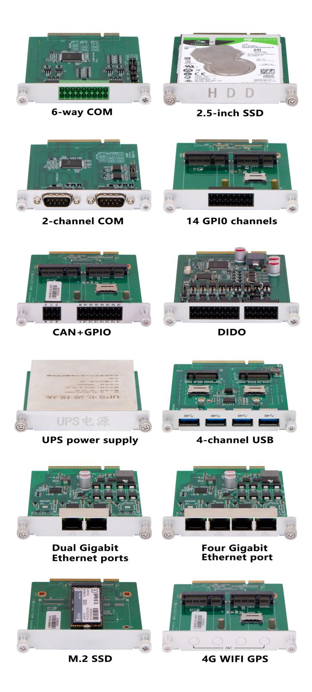
QY-B8000
3.Daughter Card Specification:
COM Port-2 | 2*RS-232 / 485 (DB9 type)
COM Port-6 | 4*RS-232 / 485+2*RS-232 (Phoenix terminal type)
Ethernet Port-2 | 2*Intel i211V LAN Chip (RJ-45 type)
Ethernet Port-4 | 4*Intel i211V LAN Chip (RJ-45 type,POE function optional)
10G Ethernet Port-2 | 2*10Gbps Ethernet ports
USB Port-4 | 4*USB 3.0 (Type-A)
GPIO Port-14 | 14 ports GPIO, 7*GPI+7*GPO, 0-3.3V (Phoenix terminal type)
DIDO Port-16 | 16 ports DIDO, 8*DI+8*DO, 24V (Phoenix terminal type)  Comes with 4*RS-485 COM ports (Phoenix terminal type)
Mini PCIE Slot-2 | 2*Mini PCIE slots, Support 4G and WIFI module
M.2 Slot-1 | 1*M.2 Key-B slot, Support 5G module
M.2 NVME SSD Slot-1 | 1*M.2 NVME SSD slot
SATA SSD Slot-1 | 1*SATA 3.0 SSD Slot, Support RAID 1
CAN Port-2 | 2*CAN interfaces (Phoenix terminal type)
UPS battery | 1.2AH or 4.8AH

QY-B8000
4.Ordering Information:
Model | CPU | LAN | USB | COM | RAM | Display | SSD | Expansion | Power
QY-P8104 | J1900 | 2 | 4 | 2*RS-232/422/485  4*RS-232 | 1*DDR 3  Up to 8GB | 1*HDMI | 1*MSATA  1*SATA | 1*Mini PCIE | DC 9-36V
QY-P8104 | 4th | 2 | 4 | 2*RS-232/422/485  4*RS-232 | 2*DDR 3  Up to 16GB
QY-P8104 | N95 / N100 | 2 | 4 | 2*RS-232/422/485  4*RS-232 | 1*DDR 4  Up to 16GB
QY-P8104 | J6412 | 2 | 4 | 2*RS-232/422/485  4*RS-232 | 2*DDR 4  Up to 32GB
QY-P8104 | 7th | 2 | 4 | 2*RS-232/422/485  4*RS-232 | 2*DDR 4  Up to 32GB
QY-P8104 | 8th / 10th | 2 | 4 | 2*RS-232/422/485  4*RS-232 | 2*DDR 4  Up to 64GB
QY-P8104 | 11th / 12th | 2 | 4 | 2*RS-232/422/485  4*RS-232 | 2*DDR 4  Up to 64GB | 1*HDMI | 1*M.2 NVME | 1*Mini PCIE  1*M.2 | DC 9-36V

5.CPU Information:
QY-B8000
5.CPU Information:
CPU | Specification
J1900 | 4 core, 4 total threads, 2.00 GHz to 2.42GHz, 2 MB cache | Max to 8GB for 1*DDR 3 Slot
i3-4010U | 2 core, 4 total threads, 1.70 GHz, 3 MB Cache | Max to 16GB for 2*DDR 3 Slots
i5-4260U | 2 core, 4 total threads, 1.40 GHz to 2.70GHz, 3 MB cache | Max to 16GB for 2*DDR 3 Slots
i7-4650U | 2 core, 4 total threads, 1.70 GHz to 3.30GHz, 4 MB cache | Max to 16GB for 2*DDR 3 Slots
J6412 | 4 core, 4 total threads, 2.00 GHz to 2.60GHz, 1.5 MB cache | Max to 32GB for 2*DDR 4 Slots
N95 | 4 core, 4 total threads, 3.40 GHz, 6 MB cache | Max to 16GB for 1*DDR 4 Slot
N100 | 4 core, 4 total threads, 3.40 GHz, 6 MB cache | Max to 16GB for 1*DDR 4 Slot
i3-7100U | 2 core, 4 total threads, 2.40 GHz, 3MB cache | Max to 32GB for 2*DDR 4 Slots
i5-7200U | 2 core, 4 total threads, 2.50 GHz to 3.10GHz, 3 MB cache | Max to 32GB for 2*DDR 4 Slots
i7-7500U | 2 core, 4 total threads, 2.70 GHz to 3.50GHz, 4 MB cache | Max to 32GB for 2*DDR 4 Slots
i3-8130U | 2 core, 4 total threads, 2.20 GHz to 3.40 GHz, 4 MB cache | Max to 32GB for 2*DDR 4 Slots
i5-8250U | 4 core, 8 total threads, 1.60 GHz to 3.40 GHz, 6 MB cache | Max to 32GB for 2*DDR 4 Slots
i5-8260U | 4 core, 8 total threads, 1.60 GHz to 3.90 GHz, 6 MB cache | Max to 64GB for 2*DDR 4 Slots
i7-8550U | 4 core, 8 total threads, 1.80 GHz to 4.00 GHz, 6 MB cache | Max to 32GB for 2*DDR 4 Slots
i3-10110U | 2 core, 4 total threads, 2.10 GHz to 4.10 GHz, 6 MB cache | Max to 64GB for 2*DDR 4 Slots
i5-10210U | 4 core, 8 total threads, 1.60 GHz to 4.20 GHz, 6 MB cache | Max to 64GB for 2*DDR 4 Slots
i7-10710U | 6 core, 12 total threads, 1.60 GHz to 4.70 GHz, 12 MB cache | Max to 64GB for 2*DDR 4 Slots
i3-1115G4 | 2 core, 4 total threads, 4.10 GHz, 6 MB cache | Max to 64GB for 2*DDR 4 Slots
i5-1135G7 | 4 core, 8 total threads, 4.20 GHz, 8 MB cache | Max to 64GB for 2*DDR 4 Slots
i7-1195G7 | 4 core, 8 total threads, 2.90 GHz to 5.00 GHz, 8 MB cache | Max to 64GB for 2*DDR 4 Slots
i3-1215U | 6 core, 8 total threads, 3.30 GHz to 4.40 GHz, 10 MB cache | Max to 64GB for 2*DDR 4 Slots
i5-1235U | 10 core, 12 total threads, 3.30 GHz to 4.40 GHz, 12 MB cache | Max to 64GB for 2*DDR 4 Slots
i7-1255U | 10 core, 12 total threads, 3.50 GHz to 4.70 GHz, 12 MB cache | Max to 64GB for 2*DDR 4 Slots
i7-1270P | 12 core, 16 total threads, 3.50 GHz to 4.80 GHz, 18 MB cache | Max to 64GB for 2*DDR 4 Slots

CPU | System
J1900 | Windows 7 / 10 and Linux
4th / 7th | Windows 7 / 10 and Linux
J6412 / N95 / N100 | Windows 10 / 11 and Linux
8th / 10th  11th / 12th | Windows 10 / 11 and Linux
QY-B8000
6.System Information:

7.Fittings Information:

RAM | DDR 3 | 4GB / 8GB
RAM | DDR 4 | 4GB / 8GB / 16GB / 32GB
Storage | MSATA | 64GB / 128GB / 256GB / 512GB / 1TB
Storage | M.2 NVME | 128GB / 256GB / 512GB / 1TB / 2TB / 4TB
Storage | SATA | 120GB / 128GB / 240GB / 256GB / 480GB / 512GB / 960GB / 1TB / 2TB / 4TB
GSM Module | 4G | 4G+GPS
GSM Module | 5G | 5G+GPS
WIFI Module | 7260AN / 7260AC / AX210
CAN BUS Module | 2*CAN BUS Ports

8.Package List:
QY-B8000

Adapter | 1*12V 5A Adapter
Power Cable | 1*Power Cable
Terminal | 2 Pin Phoenix Terminal For Power Switch
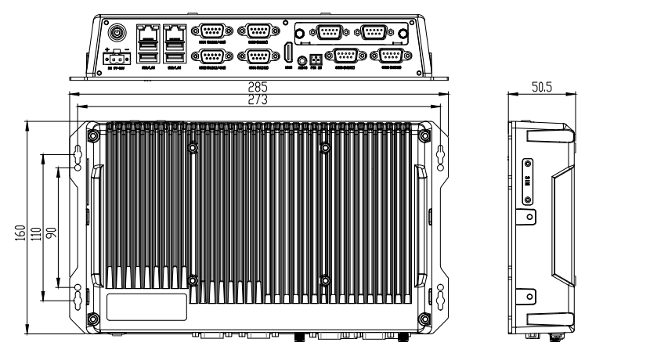
9.Dimensions:

